**Notebook of React.js**

**What is React?**

* React is a front-end JavaScript library developed by Facebook in 2011.
* It follows the component-based approach which helps in building reusable UI components.
* It is used for developing complex and interactive web and mobile UI.
* Even though it was open sourced only in 2015, it has one of the largest communities supporting it.

**What are the features of React?**

Major features of React are listed below:

1. It uses the **virtual DOM** instead of the real DOM.
2. It uses **server-side rendering**.
3. It follows **uni-directional data flow** or data binding.

### ****What is JSX?****

JSX is a shorthand for JavaScript XML.

JSX is NOT HTML but it looks a lot like it. Differences can be seen when looking closely though (for example className in JSX vs class in "normal HTML"). JSX is just syntactic sugar for JavaScript, allowing you to write HTMLish code instead of nested React.createElement(...) calls.

### ****What do you understand by Virtual DOM? Explain its working.****

A virtual DOM is a lightweight JavaScript object which originally is just the copy of the real DOM. It is a node tree that lists the elements, their attributes and content as Objects and their properties. React’s render function creates a node tree out of the React components. It then updates this tree in response to the mutations in the data model which is caused by various actions done by the user or by the system.  
This Virtual DOM works in three simple steps.

1. Whenever any underlying data changes, the entire UI is re-rendered in Virtual DOM representation.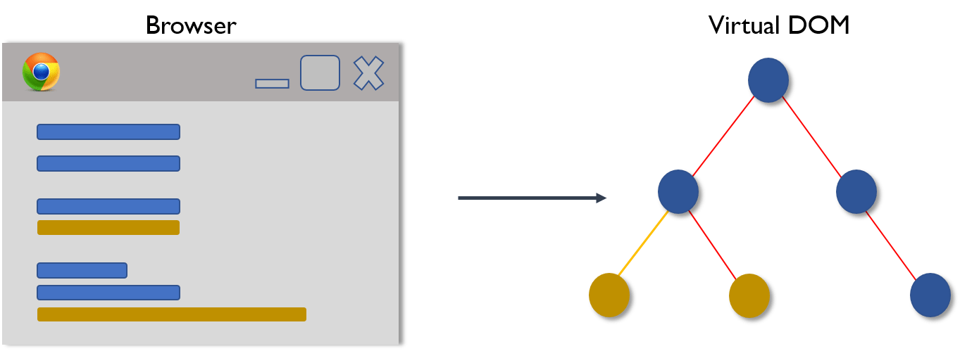
2. Then the difference between the previous DOM representation and the new one is calculated.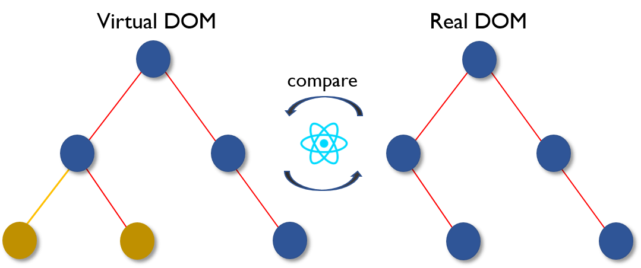
3. Once the calculations are done, the real DOM will be updated with only the things that have actually changed. 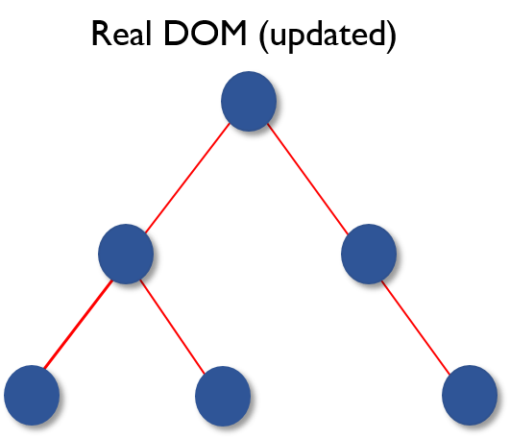

### ****Why can’t browsers read JSX?****

Browsers can only read JavaScript objects but JSX in not a regular JavaScript object. Thus, to enable a browser to read JSX, first, we need to transform JSX file into a JavaScript object using JSX transformers like Babel and then pass it to the browser.

### ****“In React, everything is a component.” Explain.****

Components are the building blocks of a React application’s UI. These components split up the entire UI into small independent and reusable pieces. Then it renders each of these components independent of each other without affecting the rest of the UI.

### ****How is React different from Angular?****

|  |  |  |
| --- | --- | --- |
| **React vs Angular** | | |
| **TOPIC** | **REACT** | **ANGULAR** |
| 1. ARCHITECTURE | Only the View of MVC | Complete MVC |
| 2. RENDERING | Server-side rendering | Client-side rendering |
| 3. DOM | Uses virtual DOM | Uses real DOM |
| 4. DATA BINDING | One-way data binding | Two-way data binding |
| 5. DEBUGGING | Compile time debugging | Runtime debugging |
| 6. AUTHOR | Facebook | Google |

### ****What is the purpose of render() in React.****

Each React component must have a **render()**mandatorily. It returns a single React element which is the representation of the native DOM component. If more than one HTML element needs to be rendered, then they must be grouped together inside one enclosing tag such as **<form>, <group>,<div>** etc. This function must be kept pure i.e., it must return the same result each time it is invoked.

### ****What is a state in React and how is it used?****

States are the heart of React components. States are the source of data and must be kept as simple as possible. Basically, states are the objects which determine components rendering and behavior. They are mutable unlike the props and create dynamic and interactive components. They are accessed via **this.state().**

### ****What are the different phases of React component’s lifecycle?****

There are three different phases of React component’s lifecycle:

1. Initial Rendering Phase: This is the phase when the component is about to start its life journey and make its way to the DOM.
2. Updating Phase: Once the component gets added to the DOM, it can potentially update and re-render only when a prop or state change occurs. That happens only in this phase.
3. Unmounting Phase: This is the final phase of a component’s life cycle in which the component is destroyed and removed from the DOM.

#### **Mounting**

These methods are called in the following order when an instance of a component is being created and inserted into the DOM:

* [**constructor()**](https://reactjs.org/docs/react-component.html#constructor)
* [static getDerivedStateFromProps()](https://reactjs.org/docs/react-component.html#static-getderivedstatefromprops)
* [**render()**](https://reactjs.org/docs/react-component.html#render)
* [**componentDidMount()**](https://reactjs.org/docs/react-component.html#componentdidmount)

**constructor**:

The constructor for a React component is called before it is mounted. When implementing the constructor for a React.Component subclass, you should call super(props) before any other statement. Otherwise, this.props will be undefined in the constructor, which can lead to bugs.

Typically, in React constructors are only used for two purposes:

* Initializing [local state](https://reactjs.org/docs/state-and-lifecycle.html) by assigning an object to this.state.
* Binding [event handler](https://reactjs.org/docs/handling-events.html) methods to an instance.

Constructor is the only place where you should assign this.state directly. In all other methods, you need to use this.setState() instead.

Avoid introducing any side-effects or subscriptions in the constructor. For those use cases, use componentDidMount() instead.

Render Method:

The render() function should be pure, meaning that it does not modify component state, it returns the same result each time it’s invoked, and it does not directly interact with the browser.

ComponentDidMount():

ComponentDidMount () is invoked immediately after a component is mounted (inserted into the tree). Initialization that requires DOM nodes should go here. If you need to load data from a remote endpoint, this is a good place to instantiate the network request.

This method is a good place to set up any subscriptions. If you do that, don’t forget to unsubscribe in componentWillUnmount()

**Updating Phase:**

### componentDidUpdate

componentDidUpdate() is invoked immediately after updating occurs. This method is not called for the initial render.

Use this as an opportunity to operate on the DOM when the component has been updated. This is also a good place to do network requests as long as you compare the current props to previous props (e.g. a network request may not be necessary if the props have not changed).

Unmounting Phase

**componentWillUnmount()** is invoked immediately before a component is unmounted and destroyed. Perform any necessary cleanup in this method, such as invalidating timers, canceling network requests, or cleaning up any subscriptions that were created in componentDidMount().

You **should not call setState()** in componentWillUnmount() because the component will never be re-rendered. Once a component instance is unmounted, it will never be mounted again.

### ****What is an event in React?****

In React, events are the triggered reactions to specific actions like mouse hover, mouse click, key press, etc. Handling these events are similar to handling events in DOM elements. But there are some syntactical differences like:

1. Events are named using camel case instead of just using the lowercase.
2. Events are passed as functions instead of strings.

The event argument contains a set of properties, which are specific to an event. Each event type contains its own properties and behavior which can be accessed via its event handler only.

### ****What are Higher Order Components(HOC)?****

Higher Order Component is an advanced way of reusing the component logic. Basically, it’s a pattern that is derived from React’s compositional nature. HOC are custom components which wrap another component within it. They can accept any dynamically provided child component but they won’t modify or copy any behavior from their input components. You can say that HOC are ‘pure’ components.

### ****What is the significance of keys in React?****

Keys are used for identifying unique Virtual DOM Elements with their corresponding data driving the UI. They help React to optimize the rendering by recycling all the existing elements in the DOM. These keys must be a unique number or string, using which React just reorders the elements instead of re-rendering them. This leads to increase in application’s performance.

### ****Explain Flux.****

Flux is an architectural pattern which enforces the uni-directional data flow. It controls derived data and enables communication between multiple components using a central Store which has authority for all data. Any update in data throughout the application must occur here only. Flux provides stability to the application and reduces run-time errors.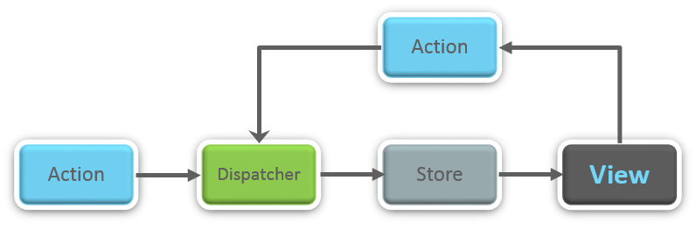

### ****What is Redux?****

Redux is one of the most trending libraries for front-end development in today’s marketplace. It is a predictable state container for JavaScript applications and is used for the entire applications state management. Applications developed with Redux are easy to test and can run in different environments showing consistent behavior.

### ****What are the three principles that Redux follows?****

1. ***Single source of truth:***The state of the entire application is stored in an object/ state tree within a single store. The single state tree makes it easier to keep track of changes over time and debug or inspect the application.
2. **State is read-only:**The only way to change the state is to trigger an action. An action is a plain JS object describing the change. Just like state is the minimal representation of data, the action is the minimal representation of the change to that data.
3. ***Changes are made with pure functions:*** In order to specify how the state tree is transformed by actions, you need pure functions. Pure functions are those whose return value depends solely on the values of their arguments.